|  |
| --- |
| **Church News**  radiYAte Weekend Away  Young adults weekend away is happening Sept 14-16! Our speaker is James Chen. Registrations still open!  FRESH in August  We'll be running 5 weeks of supper and dialogue for our non-Christian friends starting August 8 in Kingsgrove. Think about whether you'd like to come and who you can invite. To help us prepare for it, and to get an idea of its format, we're running ‘PRE-FRESH' on Wed August 1 at 7.30pm in the hall.  Reachout Missions Conference (Sept 8-9 in Katoomba)  God calls all to partake in His great mission, whether you are looking to go short term/long term or still trying to figure out. ReachOut conference is a good way to learn more about missions and different opportunities available.  See PT (from Bankstown) if interested. You can also RSVP on Facebook: <https://www.facebook.com/events/457380904713427/>  Support Gospel work at SWEC!  Generous financial partners are needed to help grow the ministry of Gospel work at SWEC.  Please consider partnering with SWEC by setting up electronic giving.  For information on how to set this up, email [give@swec.org.au](mailto:give@swec.org.au)  Evangelism Tabletalk  We want to be better at sharing the good news of Jesus but how do we do it? What do you do when the hard questions come up? Come join us as we discuss the questions we face and how we should respond. 12th August 9:30am at All Good Things Cafe. See Grace Yam for more info. |

|  |  |  |  |  |  |  |  |
| --- | --- | --- | --- | --- | --- | --- | --- |
| **Upcoming Events**  August  1st - Pre-FRESH (7.30pm Kingsgrove hall)  5th – Congregational Prayer Meetings (10am)  8th – FRESH begins (Every Wed for 5 weeks, 7.30pm Kingsgrove)  12th – Evangelism Table Talk (9.30am All Good Things Café)  18th – RICE Rally | **Stay Connected**   |  |  | | --- | --- | |  | fb.com/swechurch | |  | @swechurch | |  | swec.org.au/newsletter | |

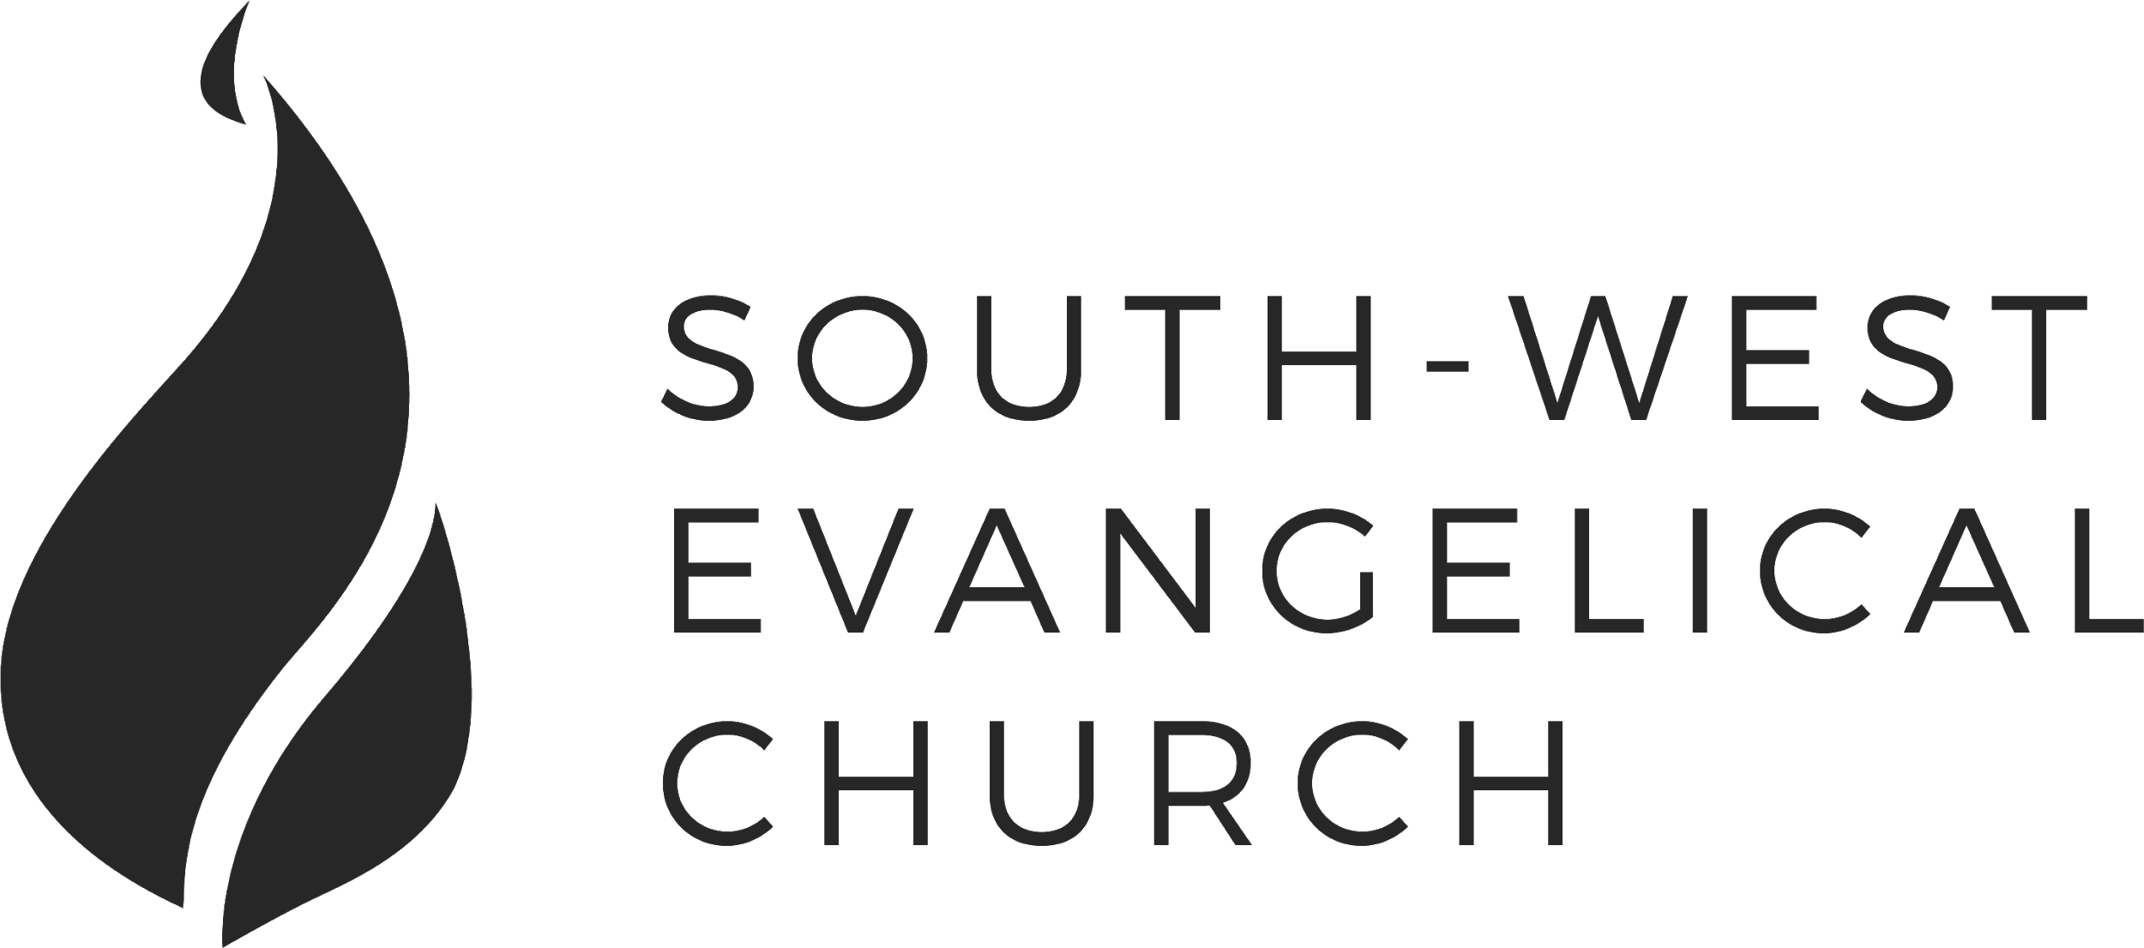

Sunday, 22 July 2018 | 11am English | [www.swec.org.au](http://www.swec.org.au)

Pastor Peter Ko | 0433 493 488 | pko@swec.org.au

What we’ll be doing during our time together

1. Worship

We’ll be worshipping God through song, prayer and by hearing His word.

Today’s confession prayer

Merciful God, our maker and our judge, we have sinned against you in thought, word, and deed:  
we have not loved you with our whole heart, we have not loved our neighbours as ourselves:  
we repent, and are sorry for all our sins.  
Father, forgive us.  
Strengthen us to love and obey you in newness of life;  
through Jesus Christ our Lord.  
Amen

Bible reading - Judges 13:1-5, 24-25

2. Community

An opportunity to get updated with what’s happening at SWEC!

3. Prayer

We’ll be praying for various needs in our church, the wider community, and the world.

4. God’s Word

Today’s sermon will be given by Peter Ko.

5. Response

An opportunity for us to respond by singing, through holy communion, and by financial giving.

6. Blessing & Sending  
Go with God’s blessing to love and serve him and the world.

|  |  |  |
| --- | --- | --- |
| **Pastors**  Peter Ko (Lead Pastor)  Stephen Fei  Dom Cheung  Karen Ko | **Elders**  Johnson Lee  Andrew Lim  Kirby Wong  Nelson Siu  board@swec.org.au | **Student Pastors**  Andrew Hayes  James Hoey  **Ministry Intern**  Lisa Truong |

It’s All Good

1 Corinthians 7

Introduction  
  
1. Issues and Overview  
  
2. Marriage and Singleness  
  
        a. What difference did Jesus make then?  
  
        b. What difference does Jesus make now?  
  
3. Why Jesus Makes All The Difference  
  
        a. Be content to remain as you are (17-24)  
  
        b. This life ain’t it (29-31)  
  
4. Application  
  
        a. Marrieds  
  
        b. Singles  
  
5. Q&A

Today’s Sermon Code: **R7H**

Zacpages is ending its service at the end of this month.

Please export any saved notes that you have written on   
Zacpages before the end of the month. Thank you!

